Condo Apartment

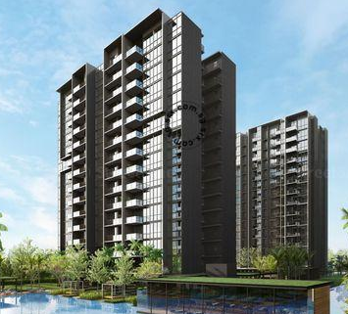 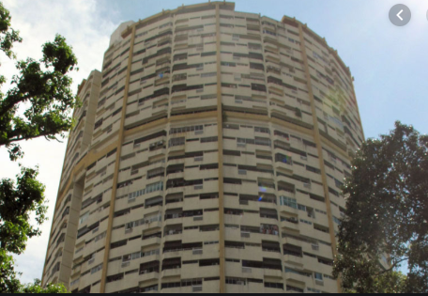

EC (Gov subsidised Condo) Terrace

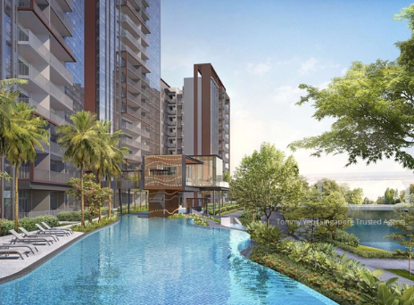 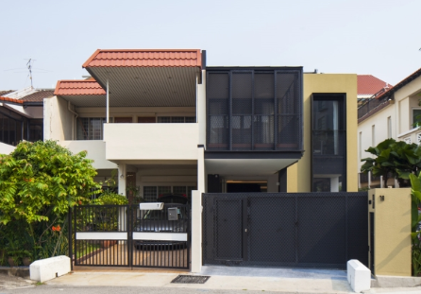

Semi-detached Strata Terrace

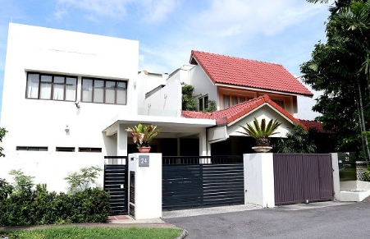 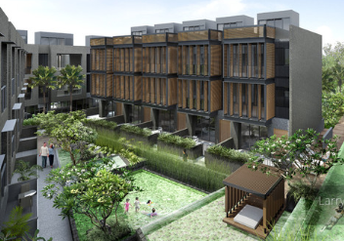

Detached Strate Semi-detached

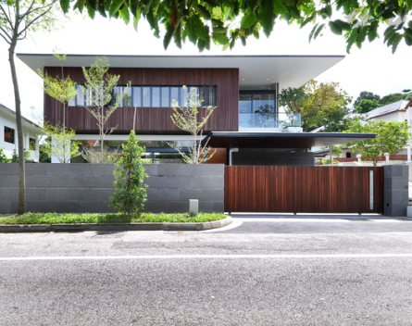 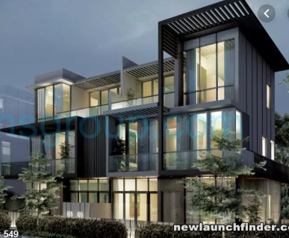

Strata Detached

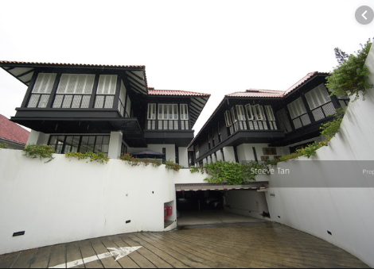

Condo:

-has common facilities e.g. pool, tennis, gymetc.

-total land area of at least 4,00sqm

-less than 40% of the area can be residential area so >=60% of area are for common facilities

Apartment:

-does not have full facilities

-area can be <4000sqm, it can be just a stand alone building

EC:

-EC will convert to condo after 10 years. It’s government sponsored condo

-all are under 99-year lease

Summary of the minimum plot widths and plot sizes for each property type

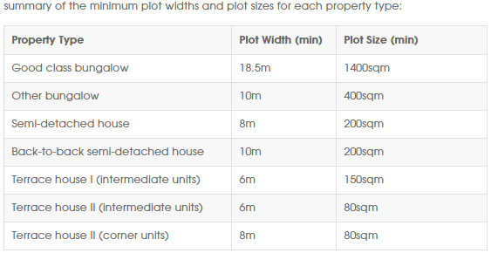

Terrace:

-a row of houses of at least 3 units with 2 corners (corner houses are bigger and of higher values than houses in the middle)

-corner houses are bigger with frontage of min. 8 metres while the houses in the middle has frontage of min. 6 metres.

-houses share common wall in between

-terrace house 1 (non-corner) has 6m frontage and 150 sqm min size and terrace house 2 (non-corner) has frontage of 6m and mini size of 80sqm. Terrace house 2 (corner) has frontage of 8m and min size of 80sqm

Semi-detached:

-conjoint buildings with a common wall in between

-min plot size of 200 sqm, min frontage (width) of 8 metres

-back-to-back semi-detached need to have min plot width of 10m

Detached:

-standalone houses such as a bungalow (no common wall with other properties)

-two categories: bungalows vs. good class bungalows (GCB)

-min plot width of 10m and plot size of 400m, for GCB, the min. width is 18.5 and min size is 1400sqm

Strata landed vs. landed

-need to remark whether it’s strata title or individual title (e.g. freehold strata vs. freehold individual)